Project Management in Engineering HW6

Yunus Güngör 15015701

The Need for Project Management Metrics

Q1) Reporting too much metrics might confuse executives about which information is critical and which is not. Also, every metric requires measurements and calculations. This measurements and calculations might take team member’s team too much and cause a slowdown in project.

Q2) Reporting too few metrics might cause misinformation and create the illusion of a failing project even if project is going very well. Small change in a metric in small pool of metrics might cause panic in executive level. Therefore company staff must be trained about metrics and what metrics represents to prevent rush decisions.

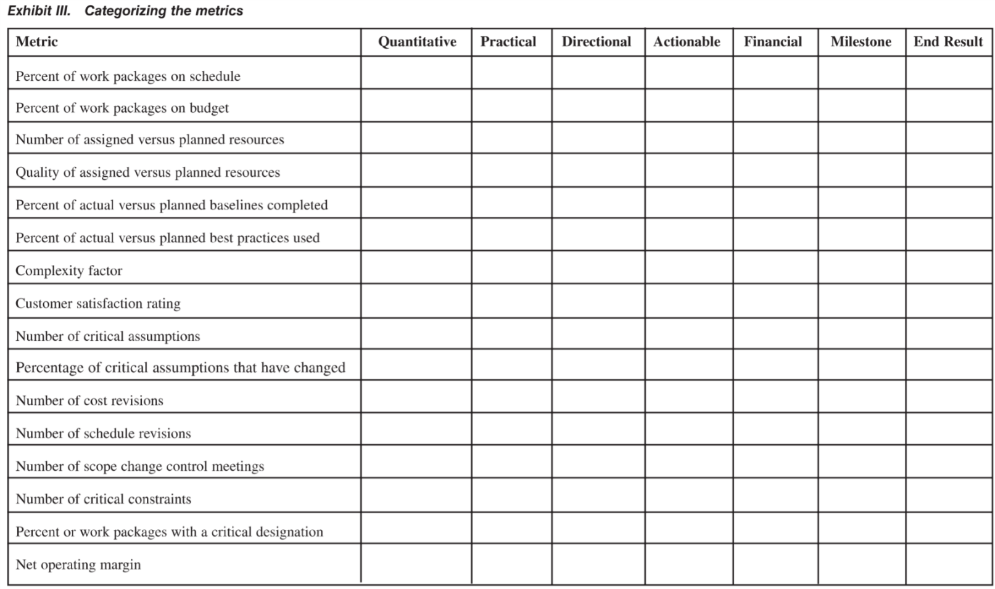Q3)

